B.C.A Project Report
Submitted in partial fulfilment of the requirements for the
“WATER CALCULATION USING FLOW SENSOR
WITH ESP8266”

Submitted by
CHETHAN N K(20231BCA0019)
KARRE GEORGE PAUL (20231BCA0043)
GUNDLUR SHAIK ABDUL REHAMAN (20231BCA0032)
GUNDE MANOJ KUMAR (20231BCA0031)
DHANUSH B (20231BCA0023)

Under the Guidance of
Dr. Riyazulla Rahman J-Senior Scale
Assistant Professor

Department of B.C.A
School of Information Science


PRESIDENCY UNIVERSITY,
BENGALURU
2025-26

Department of B.C.A
School of Information Science
Bengaluru


Certificate
This is to certify that the project entitled “WATER CALCULATION USING FLOW SENSOR WITH ESP8266” has been successfully completed by Mr Chethan N K, Mr K.George paul, G.S.Abdul Rehaman, Mr G.Manoj Kumar and Mr Dhanush B of Fifth semester BCA at Presidency University, Bengaluru, as the Internet of Things project in partial fulfilment for the award of BCA Degree course conducted by Presidency University. The Project Report presented here is the bonafide work of the students.

Guide: Head of the Department
Dr. Riyazulla Rahman Dr.Vetrimani Elangovan
Assistant Professor

Group Members:
NAME | ID
CHETHAN N K | 20231BCA0019
KARRE GEORGE PAUL | 20231BCA0043
GUNDLUR SHAIK ABDUL REHAMAN | 20231BCA0032
GUNDE MANOJ KUMAR | 20231BCA0031
DHANUSH B | 20231BCA0023

ABSTRACT
Water management and consumption monitoring have become essential in modern households, industries, and agricultural environments, where efficient usage can significantly reduce waste and operational costs. This project focuses on the design and development of an IoT-based Water Flow Measurement System using the YF-S201 Hall-effect flow sensor, ESP8266 microcontroller, and a 0.96-inch I2C OLED display. The YF-S201 sensor generates pulses proportional to the water flowing through it, and these pulses are captured by the ESP8266 using an interrupt-driven approach to ensure accurate flow detection. By applying a calibration factor, the system converts the pulse count into a real-time flow rate expressed in litres per minute, while also computing the cumulative water usage in litres.
The ESP8266 serves as the core processing unit and performs continuous data acquisition, flow calculation, and display updating. The OLED module provides an immediate visual interface that shows the current flow rate, the last measured quantity in millilitres, and the total stored water consumption. This local display allows the user to monitor water usage in real time without requiring any external device. The use of I2C communication simplifies wiring by utilizing only two pins, making the system compact and efficient for breadboard-based prototyping.
In addition to local monitoring, the system incorporates Wi-Fi connectivity to send data to the ThingSpeak cloud platform at periodic intervals. ThingSpeak stores and visualizes the uploaded values in graphical form, enabling users to remotely track water usage trends over time. The ESP8266 manages network connections, handles HTTP communication, and ensures that the posting interval complies with the platform’s minimum update requirements. This cloud integration allows the system to function as a complete IoT solution with remote accessibility.
Overall, the proposed system demonstrates a reliable, low-cost, and user-friendly approach to water flow monitoring. It effectively integrates sensing, processing, visualization, and cloud storage, making it suitable for various applications such as domestic water usage tracking, irrigation monitoring, and industrial process control. The design can be further expanded with features like leak detection, automated alerts, and multi-sensor integration for broader water management solutions.

Acknowledgement

While carrying out this project, we received guidance and support from several respected individuals to whom we express our sincere gratitude. The successful completion of this work has given us great satisfaction, and we are deeply thankful to our parents for their constant encouragement and cooperation throughout the process.
We are especially grateful to our HOD and Prof. Riyazulla Rahman J, whose valuable guidance, supervision and continuous support played an important role in completing our project. Their suggestions and motivation helped us understand the subject better and improve the quality of our work.
We once again express our heartfelt thanks to our parents for their unwavering support and encouragement, which greatly contributed to the completion of this project.

.

Table of Contents
Sl. No. | Title | Page No.
1 | Certificate | 2
2 | Abstract | 3
3 | Acknowledgement | 4
4 | Components Used | 6
5 | Features of Components Used | 6
5.1 | NODE MCU ESP8266MOD | 6
5.2 | 0.96" I2C OLED Display | 7
5.3 | (YF-S201) Water Flow Sensor | 7
5.4 | Breadboard | 8
5.5 | Jumper Wires | 8
5.6 | USB Cable | 9
5.7 | Thingspeak (CLOUD) | 9
6 | Pinout Diagram | 10
7 | Manual Connection of the Project | 11
8 | Code | 11–18
9 | README | 19-20
10 | Final Assembly | 20-21
11 | Conclusion | 21

COMPONENTS USED
- NODE MCU ESP8266MOD
- 0.96" I2C OLED Display
- (YF-S201) Water Flow Sensor
- Breadboard
- Jumper Wires
- USB Cable
- Thingspeak (CLOUD)
FEATURE OF COMPONENTS USED

1. NODE MCU ESP8266MOD
The NodeMCU ESP8266 is a low-cost, open-source firmware and development kit that allows you to build Internet of Things (IoT) products by connecting simple electronics to the internet. Technically, it is a development board built around the ESP8266 Wi-Fi System-on-Chip (SoC). Unlike a standard Arduino, the NodeMCU has built-in Wi-Fi capabilities, allowing it to function as a web server, send data to the cloud, or control devices remotely without needing extra "shields" or modules.

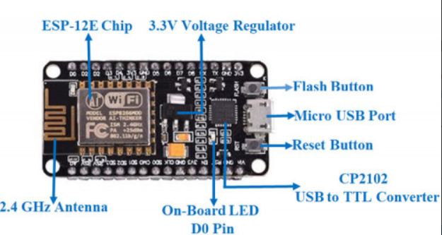

2. 0.96" I2C OLED Display
The 0.96" I2C OLED Display is a compact and popular graphic display module commonly used in hobbyist electronics and IoT projects. It typically features a resolution of 128x64 pixels, meaning it has 128 individual dots horizontally and 64 vertically, controlled by the built-in SSD1306 driver chip. Technically, the module interfaces with microcontrollers (like Arduino, ESP8266, or ESP32) using the I2C protocol, requiring only two data pins (SDA and SCL) alongside power (VCC and GND).
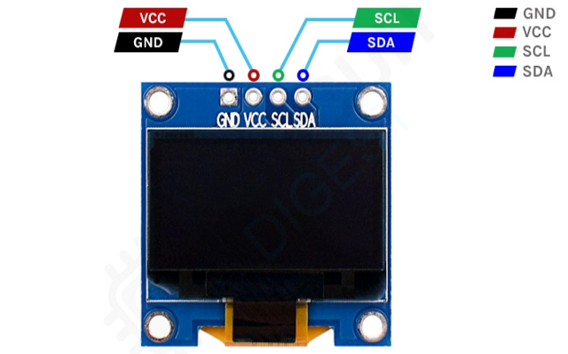

3.(YF-S201) Water Flow Sensor
The YF-S201 Water Flow Sensor is a robust and low-cost sensing component designed to measure the rate of liquid flowing through a pipe, commonly used in water dispensers, smart irrigation systems, and DIY monitoring projects. It works on the Hall Effect principle: inside its plastic valve body sits a water rotor (pinwheel) with a small magnet attached. When water flows through the valve, it pushes the rotor, causing it to spin. A magnetic Hall Effect sensor embedded in the casing detects each rotation of the magnet and outputs a corresponding electrical pulse (square wave).
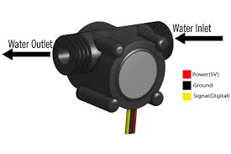
4. Breadboard
A Solderless Breadboard is a reusable construction base used for prototyping electronics without the need for permanent soldering. It allows you to insert and remove components like resistors, LEDs, and sensors quickly, making it the standard tool for testing circuit designs before creating a final Printed Circuit Board (PCB).

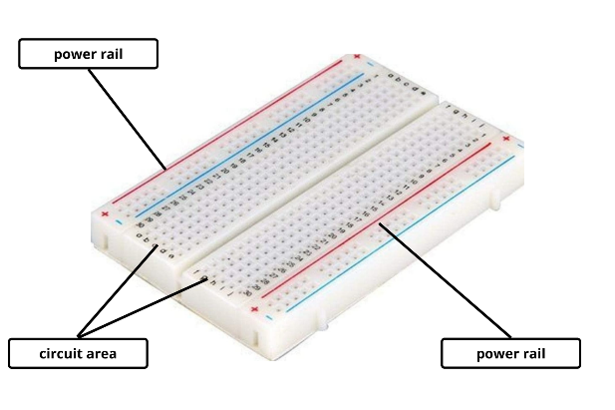

5. Jumper Wires
Jumper Wires are simple but essential electrical cables used to establish temporary connections between components on a breadboard or microcontroller without the need for soldering. They act as the "nervous system" of a prototype, carrying electrical signals and power from one point to another. These wires are typically terminated with rigid pins or plastic connectors at each end, making them easy to insert and remove as you build and modify your circuits.

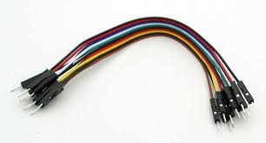
6. USB cable
In the context of electronics and microcontrollers like the NodeMCU, the USB Cable serves a dual purpose: it acts as the power supply and the communication bridge between your computer and the development board. The term stands for Universal Serial Bus. While it looks like a standard phone charger cable, it is critical for "flashing" (uploading) code from the Arduino IDE to the ESP8266 chip and for viewing serial monitor output for debugging.
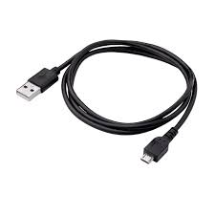
7. Thingspeak (CLOUD)
ThingSpeak is an open-source Internet of Things (IoT) analytics platform service that allows you to aggregate, visualize, and analyze live data streams in the cloud. It acts as a "data bucket" where your devices (like the NodeMCU ESP8266) can upload sensor readings, which you can then view as instant graphical charts on a website from anywhere in the world. Automatically generates line charts for your data without you needing to write any HTML or JavaScript

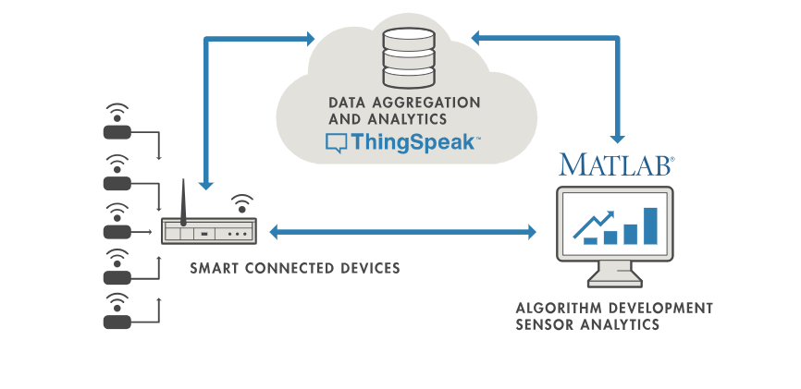
Pinout Diagram

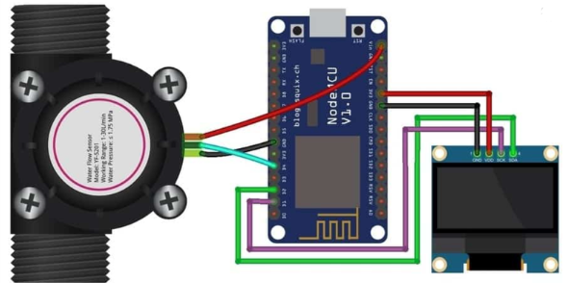

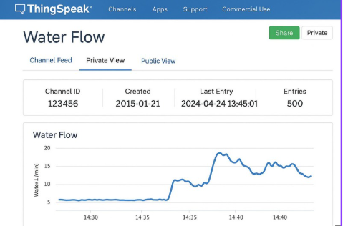

Manual Connection of the Project

Component | Wire / Pin | NodeMCU Pin
Flow Sensor | Red (Power) | 3.3V / VIN
 | Black (GND) | GND
 | Yellow (Signal) | D2
OLED Display | VCC | 3.3V / VIN
 | GND | GND
 | SDA | D2
 | SCL | D1

Manual Connection of the Project
Code
/*
ESP8266 Water Flow Meter + SSD1306 OLED + ThingSpeak
Wiring (use exactly):
Flow sensor (YF-S201):
VCC -> 5V
GND -> GND (common)
SIGNAL (yellow) -> D2 (GPIO4)

OLED SSD1306 (I2C):
VCC -> 3.3V
GND -> GND
SDA -> D3 (GPIO0)
SCL -> D4 (GPIO2)
*/
#include <ESP8266WiFi.h>
#include <ESP8266HTTPClient.h>
#include <Wire.h>
#include <Adafruit_GFX.h>
#include <Adafruit_SSD1306.h>
// ---------- CONFIG ----------
const char* ssid = "Manoj"; // <- change to your WiFi SSID
const char* password = "987654321"; // <- change to your WiFi password
const char apiKey[] = "7O2DRLS9WX9TBXFY"; // <- change to your ThingSpeak Write API key
const char hostTS[] = "api.thingspeak.com";

// Pins
#define FLOW_PIN D2 // flow sensor signal
#define SDA_PIN D3 // OLED SDA
#define SCL_PIN D4 // OLED SCL
// OLED
#define SCREEN_WIDTH 128
#define SCREEN_HEIGHT 64
Adafruit_SSD1306 display(SCREEN_WIDTH, SCREEN_HEIGHT, &Wire, -1);

// Calibration & timing
float calibrationFactor = 4.5f; // change if you need to calibrate
const unsigned long SAMPLE_MS = 1000UL; // sample every 1 second
const unsigned long THINGSPEAK_MS = 15000UL; // ThingSpeak min 15s

// Globals
volatile unsigned int pulseCount = 0; // incremented in ISR
unsigned long lastSample = 0;
unsigned long lastThingSpeak = 0;
unsigned long totalMilliLitres = 0;
float flowRate = 0.0f; // L/min

// Forward
void ICACHE_RAM_ATTR pulseCounter();

// ----------------- SETUP -----------------
void setup() {
Serial.begin(115200);
delay(100);
Serial.println();
Serial.println(F("=== Water Flow Meter starting ==="));

// Initialize I2C on safe pins (avoid conflicts with D2)
Wire.begin(SDA_PIN, SCL_PIN);

// Initialize OLED
if (!display.begin(SSD1306_SWITCHCAPVCC, 0x3C)) {
Serial.println(F("SSD1306 allocation failed - check wiring/address"));
} else {
display.clearDisplay();
display.setTextColor(WHITE);
display.setTextSize(1);
display.setCursor(0,0);
display.println("Water Flow Meter");
display.println("Initializing...");
display.display();
}
// Flow sensor pin + ISR
pinMode(FLOW_PIN, INPUT_PULLUP);
attachInterrupt(digitalPinToInterrupt(FLOW_PIN), pulseCounter, FALLING);

// Wi-Fi connect (with timeout)
WiFi.mode(WIFI_STA);
WiFi.begin(ssid, password);
Serial.printf("Connecting to WiFi '%s' ...\n", ssid);
unsigned long t0 = millis();
while (WiFi.status() != WL_CONNECTED && (millis() - t0) < 20000UL) {
Serial.print('.');
delay(300);
}
Serial.println();
if (WiFi.status() == WL_CONNECTED) {
Serial.print("WiFi connected. IP: ");
Serial.println(WiFi.localIP());
Serial.printf("RSSI: %d dBm\n", WiFi.RSSI());
} else {
Serial.println("WiFi connection failed (timeout). Will retry in loop.");
}
lastSample = millis();
lastThingSpeak = millis() - THINGSPEAK_MS; // allow immediate first post
}

// ----------------- ISR -----------------
void ICACHE_RAM_ATTR pulseCounter() {
pulseCount++;
}

// ----------------- Helper: show status on OLED -----------------
void displayStatus(const char* line1, const char* line2, const char* line3) {
if (display.width() == 0) return;
display.clearDisplay();
display.setTextSize(1);
display.setCursor(0,0);
display.println(line1);
display.println();
display.println(line2);
display.println();
display.println(line3);
display.display();
}
// ----------------- Main Loop -----------------
void loop() {
unsigned long now = millis();

// --- Sampling every SAMPLE_MS ---
if (now - lastSample >= SAMPLE_MS) {
lastSample = now;

// snapshot pulses safely
noInterrupts();
unsigned int pulses = pulseCount;
pulseCount = 0;
interrupts();

// compute using exact elapsed time (SAMPLE_MS)
// flowRate in L/min = (pulses / calibrationFactor) * (60 / seconds)
// since pulses measured over SAMPLE_MS ms, scale accordingly:
flowRate = ((1000.0f / (float)SAMPLE_MS) * (float)pulses) / calibrationFactor; // L/min

// volume during this SAMPLE_MS
float litresThisInterval = (flowRate / 60.0f); // litres in SAMPLE_MS (approx)
unsigned long mlThis = (unsigned long)(litresThisInterval * 1000.0f + 0.5f);
totalMilliLitres += mlThis;

float totalLitres = (float)totalMilliLitres / 1000.0f;

// Serial debug
Serial.printf("[Sample] Pulses=%u FlowRate=%.3f L/min ml=%lu Total=%.3f L\n",
pulses, flowRate, mlThis, totalLitres);

// OLED display
if (display.width() > 0) {
display.clearDisplay();
display.setTextSize(1);
display.setCursor(0,0);
display.print("Water Flow Meter");
display.setCursor(0,12);
display.setTextSize(2);
display.print("R:");
display.print(flowRate, 2);
display.setTextSize(1);
display.setCursor(90,18);
display.print("L/min");
display.setTextSize(1);
display.setCursor(0,40);
display.print("Last mL: ");
display.print(mlThis);
display.setCursor(0,52);
display.print("Total L: ");
display.print(totalLitres, 3);

display.display();
}
}

// --- ThingSpeak update every THINGSPEAK_MS ---
if (now - lastThingSpeak >= THINGSPEAK_MS) {
lastThingSpeak = now;

// Ensure WiFi connected (try reconnect)
if (WiFi.status() != WL_CONNECTED) {
Serial.println("WiFi not connected - attempting reconnect...");
WiFi.disconnect();
WiFi.begin(ssid, password);
unsigned long t0 = millis();
while (WiFi.status() != WL_CONNECTED && (millis() - t0) < 10000UL) {
delay(200);
}
if (WiFi.status() != WL_CONNECTED) {
Serial.println("WiFi reconnect failed - skipping ThingSpeak post");
displayStatus("ThingSpeak post skipped", "WiFi not connected", "");

} else {
Serial.print("WiFi reconnected. IP: ");
Serial.println(WiFi.localIP());
}
}

// Build HTTP POST body in a safe char buffer
float totalLitres = (float)totalMilliLitres / 1000.0f;
char postBody[128];
int blen = snprintf(postBody, sizeof(postBody),
"api_key=%s&field1=%.3f&field2=%.3f",
apiKey, flowRate, totalLitres);
if (blen <= 0) {
Serial.println("Error building POST body");

}

// Send POST using HTTPClient with WiFiClient
WiFiClient client;
HTTPClient http;
String url = String("http://") + hostTS + "/update";
Serial.println();
Serial.print("Posting to ThingSpeak: ");
Serial.println(url);
Serial.print("Body: ");
Serial.println(postBody);

http.begin(client, url); // correct API: pass WiFiClient
http.addHeader("Content-Type", "application/x-www-form-urlencoded");
int httpCode = http.POST(String(postBody)); // safe for this small payload

if (httpCode > 0) {
Serial.printf("HTTP code: %d\n", httpCode);
String payload = http.getString();
Serial.print("Response: ");
Serial.println(payload);
if (payload.toInt() > 0) {
Serial.println("ThingSpeak accepted data (entry id > 0)");
displayStatus("ThingSpeak: OK", "Posted data", payload.c_str());
} else {
Serial.println("ThingSpeak returned 0 (rate-limited or wrong key)");
displayStatus("ThingSpeak error", "Returned 0 - check key", "");
}
} else {
Serial.printf("POST failed, error: %s\n", http.errorToString(httpCode).c_str());
displayStatus("ThingSpeak POST failed", http.errorToString(httpCode).c_str(), "");
}
http.end();
}

// small yield
delay(10);
}
README
- Project Name
Title: Water Calculation using Flow Sensor.
Course: IoT Mini Project (CSA3005).
- Goal of the Project
To measure water flow rate and total water usage accurately.
To show the data on a small screen attached to the device.
To send the data to the internet (ThingSpeak cloud) so you can see graphs of water usage from anywhere.
- Hardware Parts You Need
Node MCU ESP8266: The main Wi-Fi board.
YF-S201 Water Flow Sensor: Measures the water flow (1-30 Liters/minute).
0.96" I2C OLED Display: A small screen to show numbers.
Breadboard & Jumper Wires: To connect everything without soldering.
Software You Need
Arduino IDE: To write and upload the code.
ThingSpeak: The website used to view the data charts online.
- Wiring Connections (How to Connect)
Sensor Red Wire: Connect to 3.3V Power (VIN).
Sensor Black Wire: Connect to Ground (GND).
Sensor Yellow Wire: Connect to Pin D2.
OLED Display VCC: Connect to 3.3V Power (VIN).
OLED Display GND: Connect to Ground (GND).
OLED Display SDA: Connect to Pin D2.
- Code Settings
Wi-Fi Name (SSID): Change this in the code to "Alexahome" (or your own Wi-Fi name).
Wi-Fi Password: Change this in the code to "loranthus" (or your own password).
API Key: The code uses the key KBD1JSZTUKCXJ15V to talk to ThingSpeak.

Final Assembly

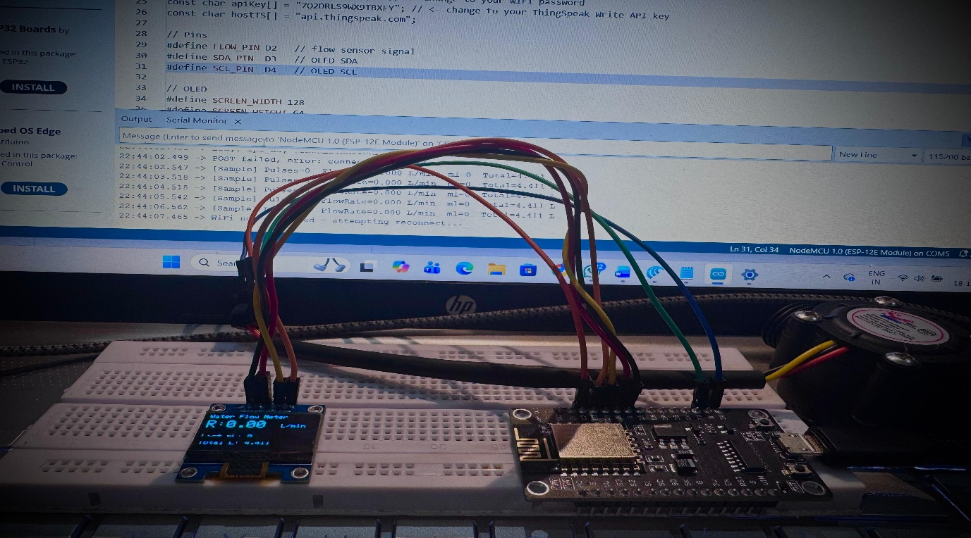

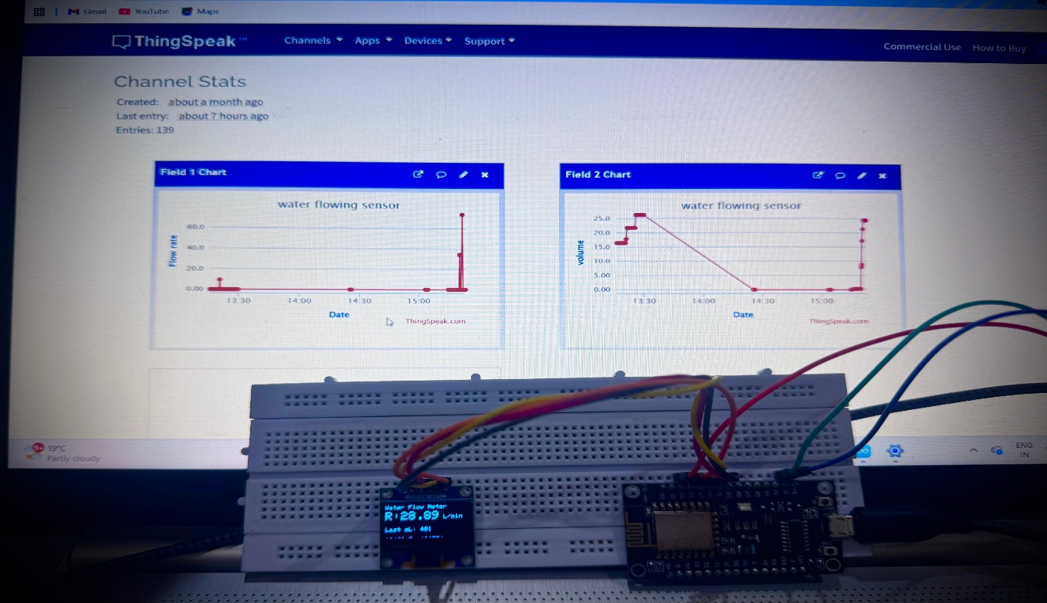

Conclusion
The IoT-based water flow monitoring system successfully demonstrates how to measure and track water usage accurately using a simple flow sensor. By integrating a NodeMCU ESP8266, the project is able to display real-time data on a local OLED screen while simultaneously transmitting flow rates and total volume to the ThingSpeak cloud for remote online monitoring. Ultimately, this project proves to be a simple and cost-effective solution that is highly useful for saving water and promoting smart resource management efficiently.

